Task 9

Question 1: Output for the given string is palindrome or not:

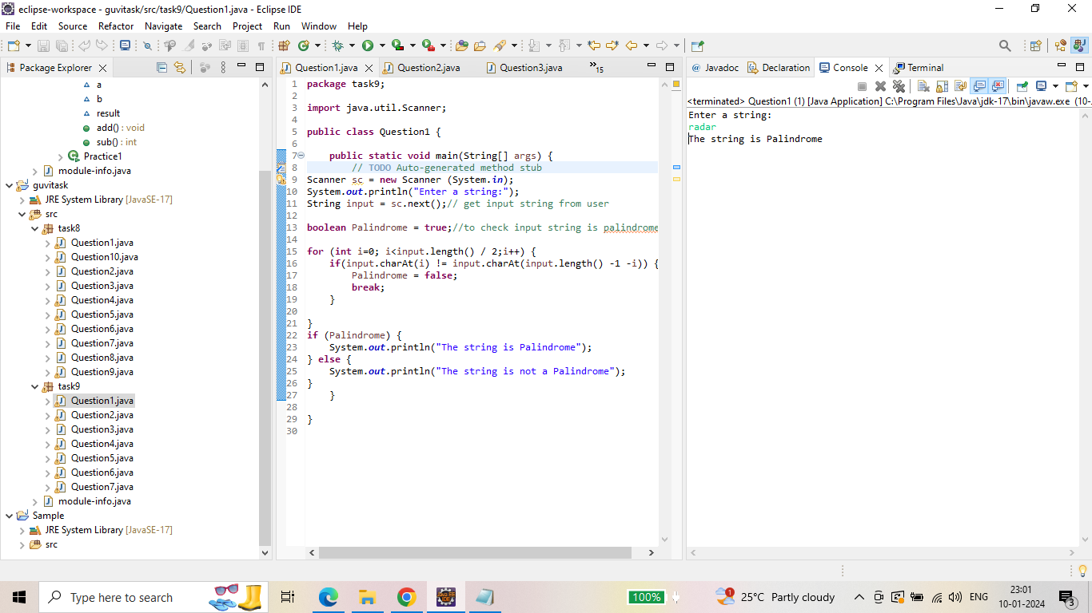

Question 2: Output for reversed string:

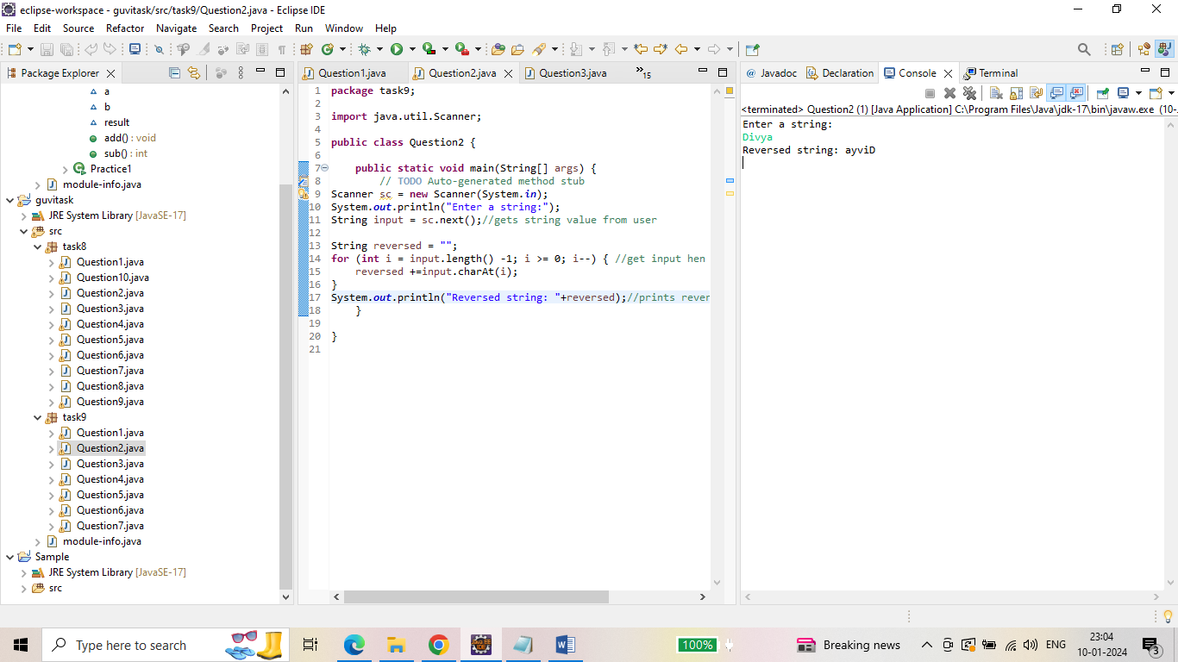

Question 3: Output for pattern problem with numbers.

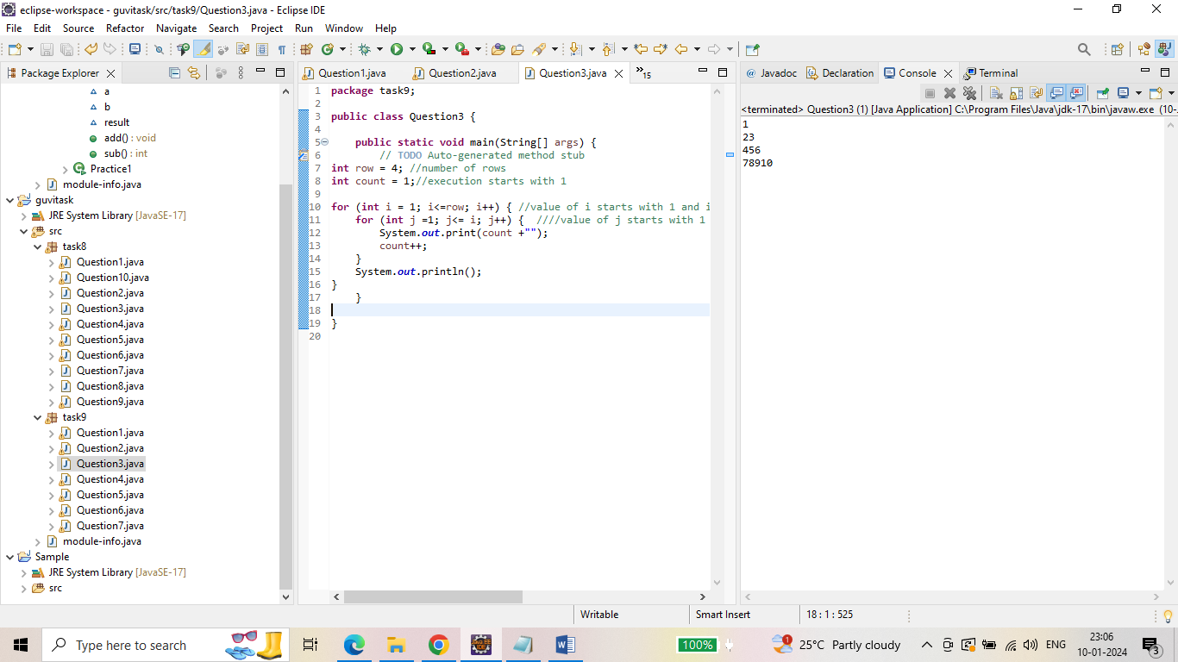

Question 4: Output for pattern problem with \*

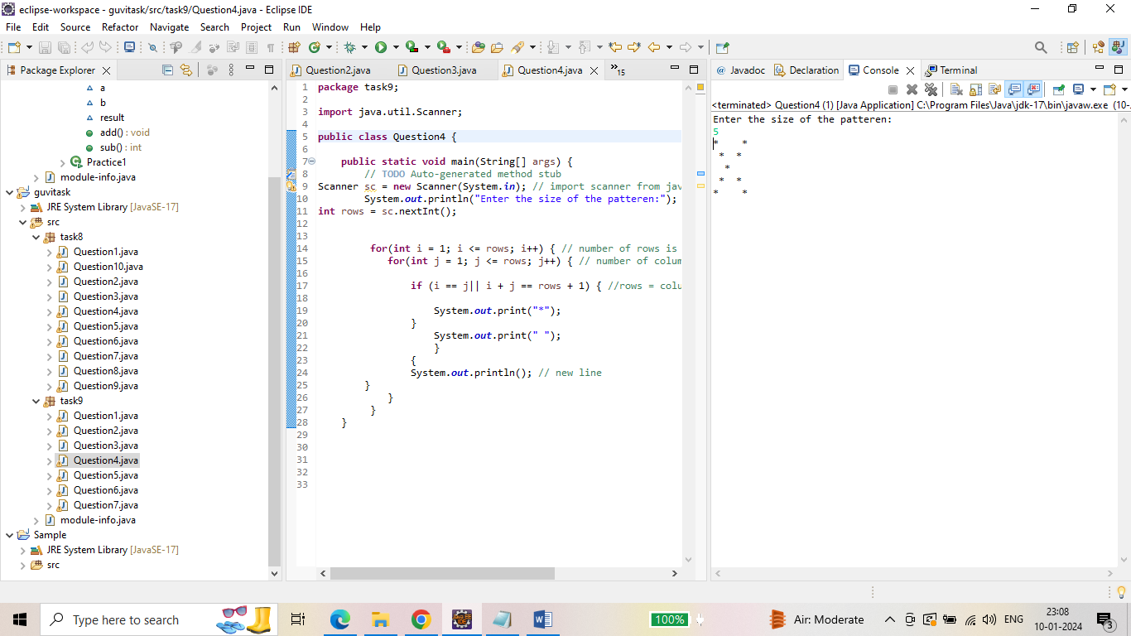

Question 5: Output for printing the grade.

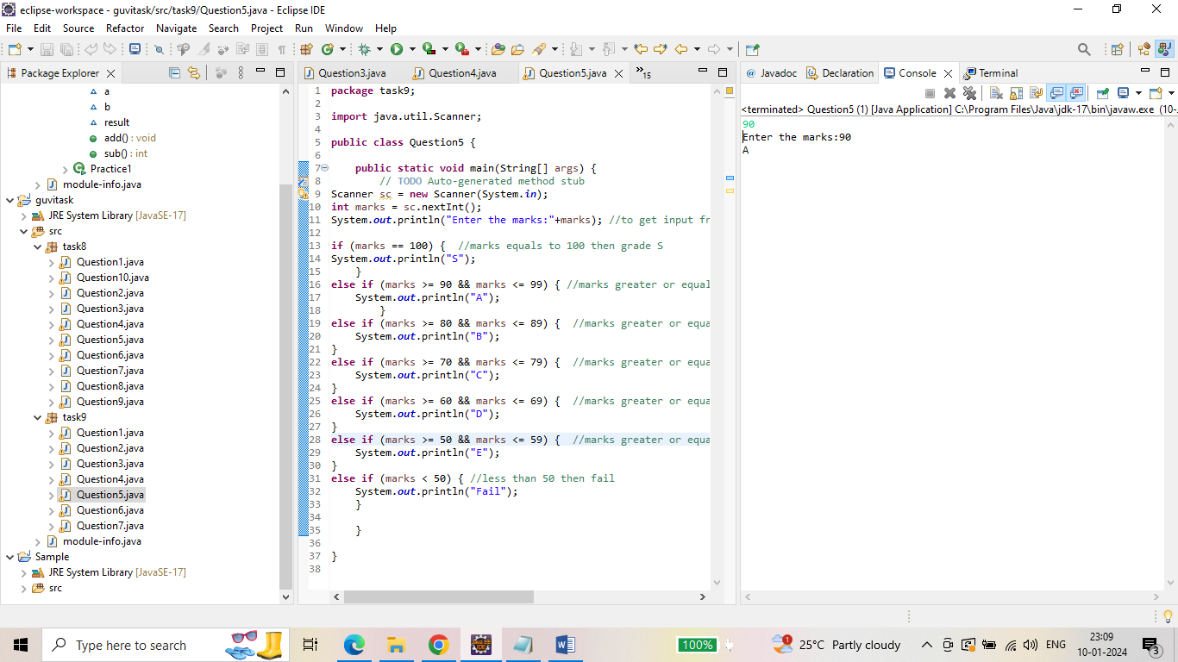

Question 6: output for hotel tariff.

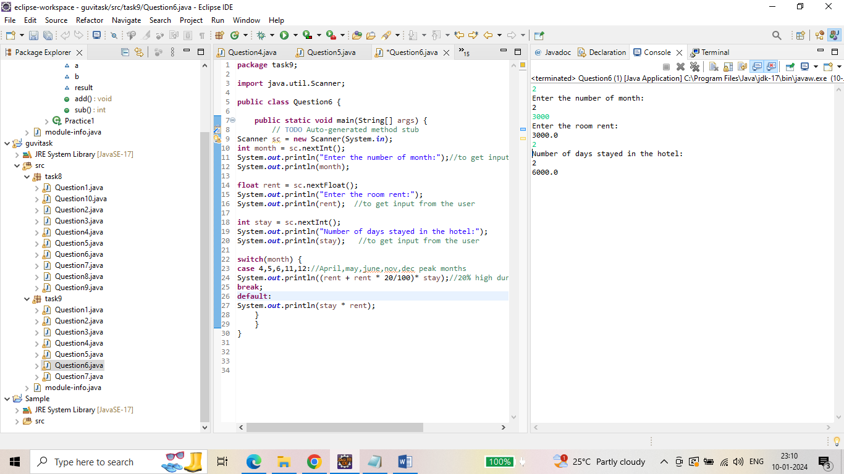

Question 7: output for printing the largest number.

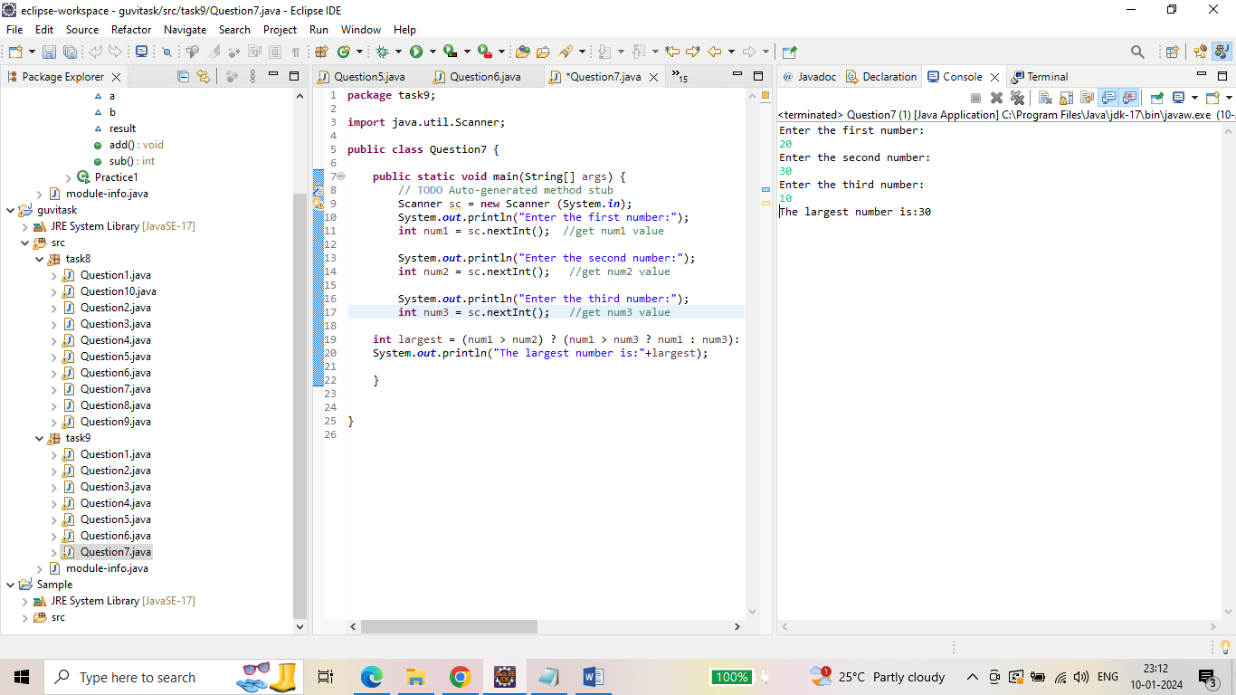

------- Thank you------